**Bikramjeet Singh**

**Answer the following questions.**

What was the App that your group created?

**Answer:**

The name of the application we created is **"Inventory Manager”**.

### Agile / Scrum

1. What did you learn about how the Agile and Scrum methodologies operate?

**Answer:**

The requirements are always creeping in **Agile Methodology**. Requirements of the user changes time to time and the developer has to make iterations according to the requirements of the client.

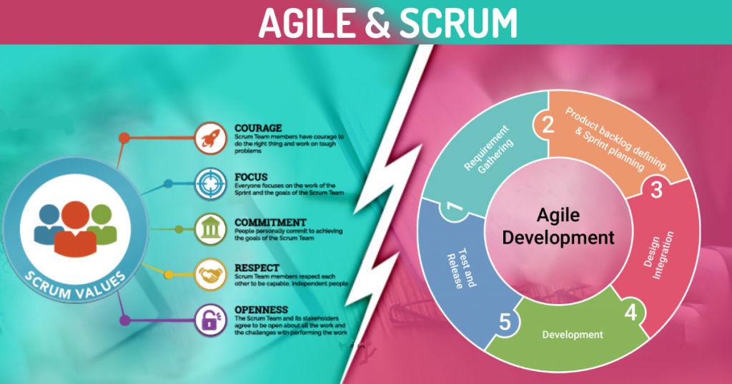

Planning is done before starting the project in the **Scrum Methodology**. All decided functionalities are divided into different sprints Each sprint is achieving one of the planned functionalities of the project. Each sprint is planned in a team meeting in the start of the sprint and a backlog is created on which all the members will follow.

1. In practice how effective did you find this methodology?

**Answer:**

All the methodologies have their own value depending on the requirement of the user if the user is uncertain about what he exactly needs then the agile methodology must be used but if all the criteria are crystal clear then scrum methodology would me a bonus.

1. What did you find was the strength of it?

**Answer:**

I find during this group project that the agile approach is more versatile, transparent, efficient and stakeholder satisfaction and responsiveness because everything is according to their understanding and needs and demands.

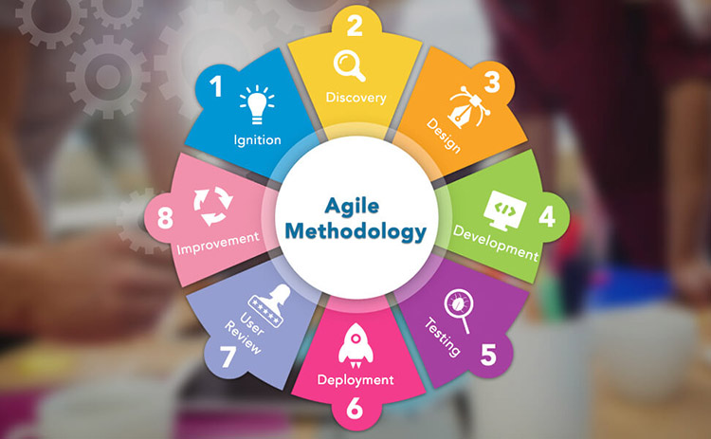

1. What were its weaknesses?

**Answer:**

The drawbacks I noticed during this group project are that the criteria of agile methodology do not always flow towards the developer finitely. Documentation is minimal because the planning is insufficient, and the findings are mostly fragmented in this approach.

1. What were the best features of the process?

**Answer:**

The features of agile methodology that are best according to me are stated as follows:

* Flexibility due to agility.
* Transparency of the project due to agility.
* Productivity of the agile methodology.

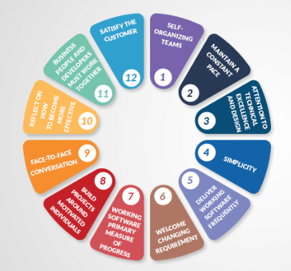

1. How did they appeal to you?

**Answer:**

These features make me more comfortable with my client as these features allow the clients to engage in all the app's growth process. Which adds to the satisfaction of the client.

1. What was the worst feature of the process?

**Answer:**

The worst feature I found in this process is the always creeping requirements from the client side. As new requirements and changes are always, there that makes the development time infinite.

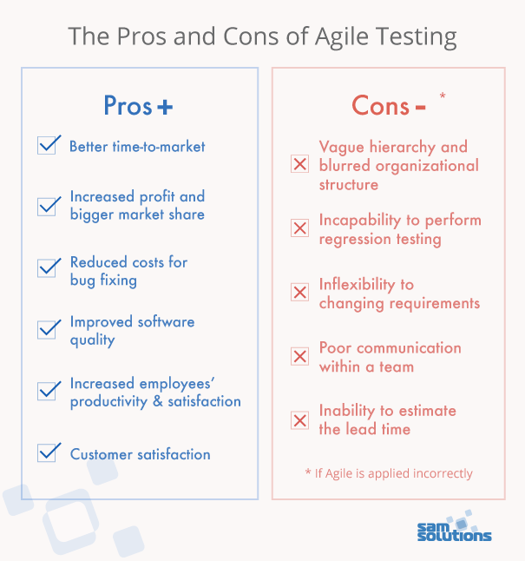

1. How would you change them?

**Answer:**

In my opinion thing must be sort out between the developer and the client reducing the creeping of the requirements.

### Group work

1. What did you enjoy about this style of programming?

**Answer:**

I enjoyed working with the project in this style because the client and the developer can see all the features and project progress that helps to increase understanding between the developer and the client.

1. What are the downsides for you of group work?

**Answer:**

I find that the group planning is disturbed as some requirement is creeped towards the developer.

1. How did this session change your opinion of working in industry?

**Answer:**

This session has changed my mind because I realize that working in a practical setting is not as easy as a college project, and certain technical and complex problems need to be handled properly, as the client is interested in the business.

### Source Control

1. What form of Source Control did you use?

**Answer:**

We used GitHub as source control of our application.



1. What were its strengths?

**Answer:**

The strengths for using GitHub are stated as follows:

* It makes it easy to contribute to the open-source project.
* Work can be show cased using GitHub.
* Changes can be easily tracked.
* We have integration options with other platforms on GitHub.

1. What were its weaknesses?

**Answer:**

The weaknesses for using GitHub are stated as follows:

* Security and pricing of the GitHub are the weaknesses of this source control platform.

1. How effective as a source control did you find it?

**Answer:**

This source control has proven extremely effective because it can be easily incorporated with any cloud and effectively managed app versions.

1. If you had to use it again, what would you change?

**Answer:**

Security requirement will be improved.

### Other

1. Do you feel that this has been a worthwhile experiment?

**Answer:**

Yes.

1. Why? Why not?

**Answer:**

I found it a worthwhile experiment as it let is gain practical experience of the agile software development life cycle.

1. **If you had to give yourself a percent grade for your contribution to the project, and the process, what would it be?** Bearing in mind that you might have produced little, yet done the hard yards. Or you made heaps, but it was really easy.

**Answer:**

I would give me an **A** because I have done a lot of effort working in the group.